Why introduce the quadratic cost? After all, aren't we primarily interested in the number of images correctly classified by the network? Why not try to maximize that number directly, rather than minimizing a proxy measure like the quadratic cost? The problem with that is that the number of images correctly classified is not a smooth function of the weights and biases in the network. For the most part, making small changes to the weights and biases won't cause any change at all in the number of training images classified correctly. That makes it difficult to figure out how to change the weights and biases to get improved performance. making small changes to the weights and biases won't cause any change at all in the number of training images classified correctly. If we instead use a smooth cost function like the quadratic cost it turns out to be easy to figure out how to make small changes in the weights and biases so as to get an improvement in the cost.

What do you mean by that ?

Earlier from cost function we came to know that, y(x) = expected output, a = actual output. making small changes to the weights and biases won't cause any change at all in the number of training images classified correctly which means the value of ∑|| y(x) - a ||² will not change that much. If the value of ∑|| y(x) - a ||² is largely positive, it will remain that if you make small changes to the weights and biases. Actually it will change very little which is negligible. Again If the value of ∑|| y(x) - a ||² is near to zero, then it means that the the number of training images classified correctly is very good and our neural network is performing very well. Now again making small changes to the weights and biases won’t cause a big change in the value of ∑|| y(x) - a ||². But this time we can try to make those negligible changes in the value of ∑|| y(x) - a ||² by making small changes to the weights and biases because now those negligible changes will make our neural network even more accurate. But don’t make the changes to the weights and biases big enough which will make the value of ∑|| y(x) - a ||² not close to zero. So we need cost function to figure out when we can make big changes to the weights and biases and when our neural network is performing well enough that we no longer need to make big changes to the weights and biases, when we can make small changes to the weights and biases to make our already performing well neural network perform more accurately.

That's why we focus first on minimizing the quadratic cost, and only after that will we examine the classification accuracy.

Even given that we want to use a smooth cost function, you may still wonder why we choose the quadratic function. Isn't this a rather ad hoc choice? Perhaps if we chose a different cost function we'd get a totally different set of minimizing weights and biases? This is a valid concern, and later we'll revisit the cost function, and make some modifications. However, the quadratic cost function works perfectly well for understanding the basics of learning in neural networks, so we'll stick with it for now. But If you are curious then here are other weight update methods that are widely used:

Neural Net Weight Update Methods

Adam | based on adaptive estimates of lower order moments
AdaGrad | Adagrad is an adaptive learning rate method
RMSProp | adaptive learning rate method, modification of Adagrad method
SGD | Stochastic gradient descent
AdaDelta | modification of Adagrad to reduce its aggressive, monotonically decreasing learning rate
Newton method | second order method, is not used in deep learning
Momentum | method that helps accelerate SGD in the relevant direction
Nesterov accelerated gradient | evaluate the gradient at next position instead of current

Recapping, our goal in training a neural network is to find weights and biases which minimize the quadratic cost function C(w,b). This is a well-posed problem, but it's got a lot of distracting structure as currently posed - the interpretation of w and b as weights and biases, the σ function lurking in the background, the choice of network architecture, MNIST, and so on. It turns out that we can understand a tremendous amount by ignoring most of that structure, and just concentrating on the minimization aspect. So for now we're going to forget all about the specific form of the cost function, the connection to neural networks, and so on. Instead, we're going to imagine that we've simply been given a function of many variables and we want to minimize that function. We're going to develop a technique called gradient descent which can be used to solve such minimization problems. Then we'll come back to the specific function we want to minimize for neural networks.

Okay, let's suppose we're trying to minimize some function, C(v). This function does not need to be quadratic function right now. This could be any real-valued function of many variables, v=v1,v2,…. Note that I've replaced the w and b notation by v to emphasize that this could be any function - we're not specifically thinking in the neural networks context any more. To minimize C(v) it helps to imagine C as a function of just two variables, which we'll call v1 and v2:
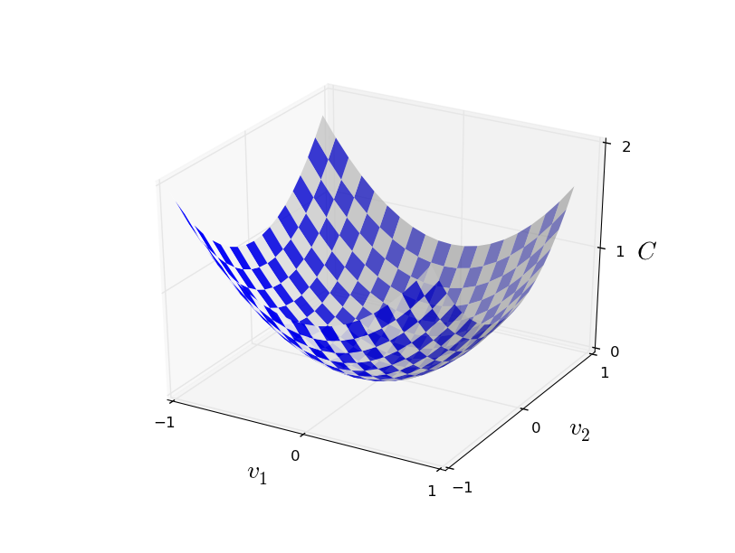
If you look carefully you can see that the above image looks like a 3D representation of the 2D graph of a quadratic function, or simply the above image looks like a 3D graph of some quadratic function. What we'd like is to find where C achieves its global minimum. Now, of course, for the function plotted above, we can eyeball the graph and find the minimum. In that sense, I've perhaps shown slightly too simple a function! A general function, C, may be a complicated function of many variables, and it won't usually be possible to just eyeball the graph to find the minimum.

Why should we emphasize on finding the minimum ?
Finding the minimum means figuring out the wights and biases for which the output of the cost function will be zero.
One way of attacking the problem is to use calculus to try to find the minimum analytically. We could compute derivatives and then try using them to find places where C is an extremum. With some luck that might work when C is a function of just one or a few variables. But it'll turn into a nightmare when we have many more variables. And for neural networks we'll often want far more variables - the biggest neural networks have cost functions which depend on billions of weights and biases in an extremely complicated way. Using calculus to minimize that just won't work!

(After asserting that we'll gain insight by imagining C as a function of just two variables, I've turned around twice in two paragraphs and said, "hey, but what if it's a function of many more than two variables?" Sorry about that. Please believe me when I say that it really does help to imagine C
as a function of two variables. It just happens that sometimes that picture breaks down, and the last two paragraphs were dealing with such breakdowns. Good thinking about mathematics often involves juggling multiple intuitive pictures, learning when it's appropriate to use each picture, and when it's not.)

Okay, so calculus doesn't work. Fortunately, there is a beautiful analogy which suggests an algorithm which works pretty well. We start by thinking of our function as a kind of a valley. If you squint just a little at the plot above, that shouldn't be too hard. And we imagine a ball rolling down the slope of the valley. Our everyday experience tells us that the ball will eventually roll to the bottom of the valley. Perhaps we can use this idea as a way to find a minimum for the function? We'd randomly choose a starting point for an (imaginary) ball, and then simulate the motion of the ball as it rolled down to the bottom of the valley. We could do this simulation simply by computing derivatives (and perhaps some second derivatives) of C - those derivatives would tell us everything we need to know about the local "shape" of the valley, and therefore how our ball should roll.

Based on what I've just written, you might suppose that we'll be trying to write down Newton's equations of motion for the ball, considering the effects of friction and gravity, and so on. Actually, we're not going to take the ball-rolling analogy quite that seriously - we're devising an algorithm to minimize C, not developing an accurate simulation of the laws of physics! The ball's-eye view is meant to stimulate our imagination, not constrain our thinking. So rather than get into all the messy details of physics, let's simply ask ourselves: if we were declared God for a day, and could make up our own laws of physics, dictating to the ball how it should roll, what law or laws of motion could we pick that would make it so the ball always rolled to the bottom of the valley?

